Chapter Book #2
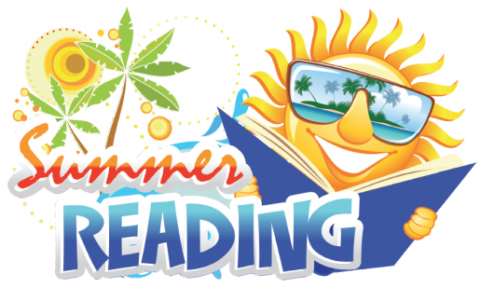
Name ___________________________________

Title of book _____________________________

_______________________________________

Author _________________________________

My book’s genre is
___ Fiction ___ Fantasy ___ Mystery ___ Historical Fiction
___ Science Fiction ___ Realistic Fiction

The characters in my book are _______________________________________________

______________________________________________________________________

My favorite scene in the book was ____________________________________________

______________________________________________________________________

______________________________________________________________________

Write a summary of the book here. A summary is a short retelling of the story in your own words.

______________________________________________________________________

______________________________________________________________________

______________________________________________________________________

______________________________________________________________________

______________________________________________________________________

______________________________________________________________________

______________________________________________________________________

______________________________________________________________________

